**Lesson 17: Area and Degrees of a Circle**

**Do Now:**

1. A rectangle has a length of 9 inches and a width of 4 inches. Find the perimeter and area.
2. Find the area and perimeter of a square with each side measuring 5 inches.
3. A rectangle has an area of 56 square feet and a width of 4 feet. What is the length?
4. A rectangular yard has a length of 16 meters and a width of 3 meters. Find the area.

**Key Vocabulary:**

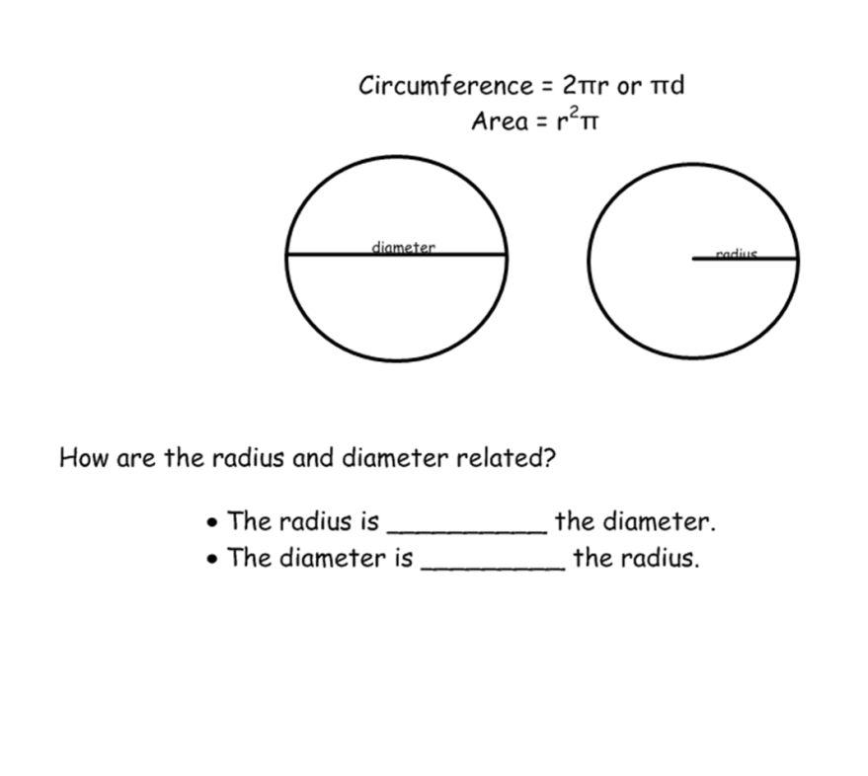

**Guided Notes:**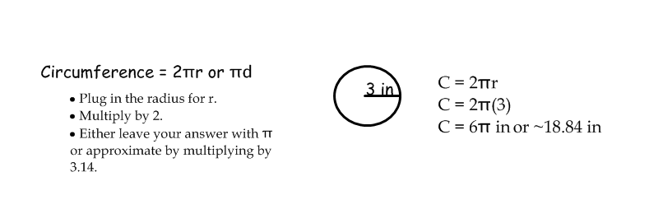

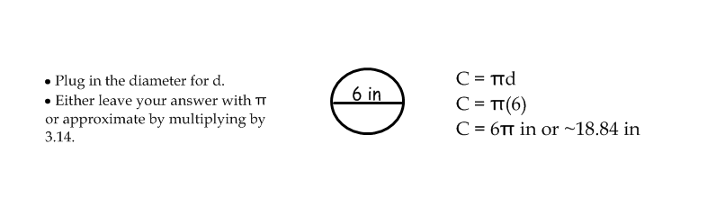

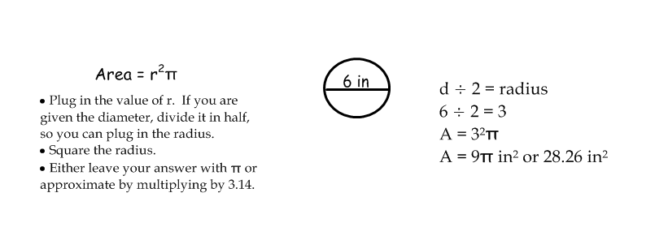

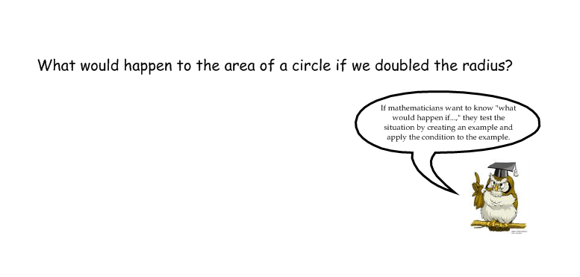

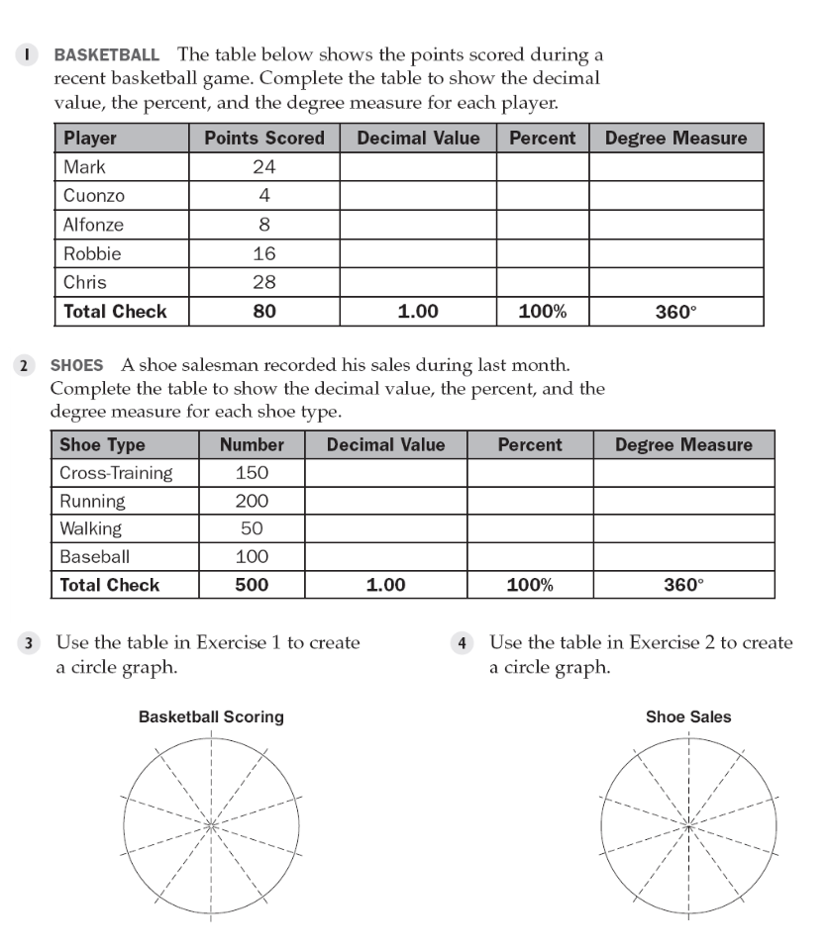

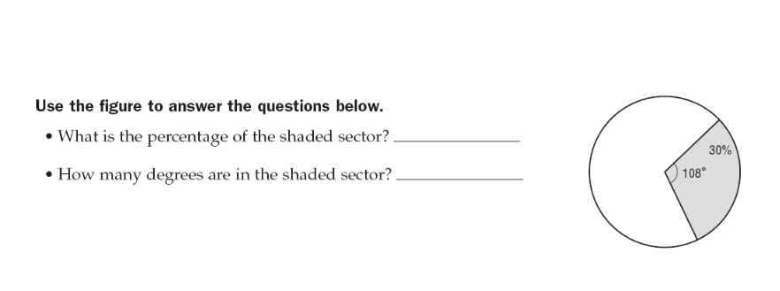

**Structured/Guided Practice:**

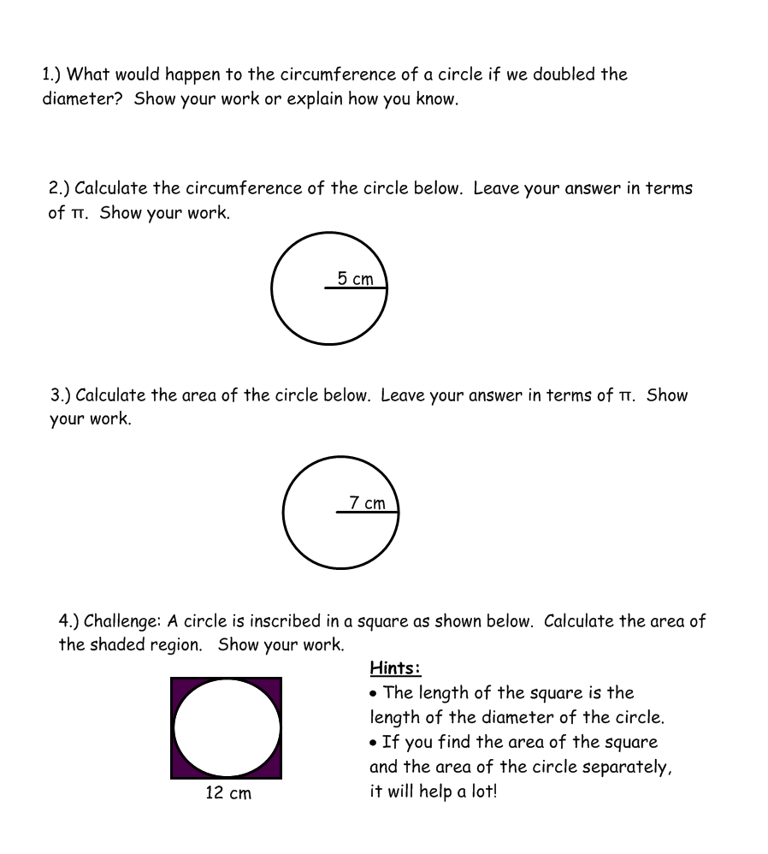

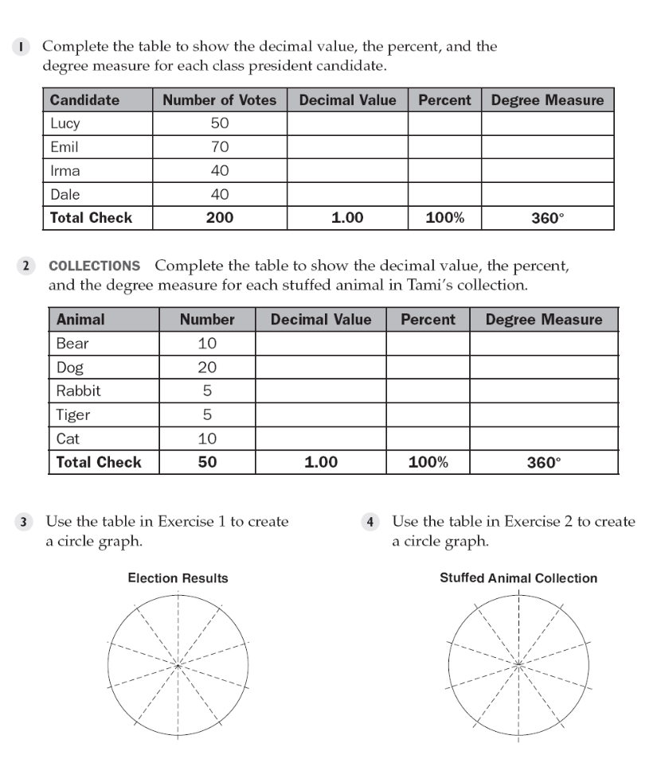

**Independent Practice:**

